



*Join Friends of ElderSource to Make More Memories*

*Saturday, September 12, 2015 at the   
Museum of Science & History (MOSH) in Jacksonville, FL*

Who We Are

* Friends of ElderSource supports ElderSource, a nonprofit, independent agency designated as Northeast Florida’s Area on Aging Agency and Aging & Disability Resource Center.
* Our Mission is to EMPOWER individuals to age with INDEPENDENCE and DIGNITY.
* We reach out to over 12,000 people each year in 7 counties – Duval, Clay, Baker, Nassau, Flagler, St. Johns, and Volusia Counties.
* We educate, advocate, support and assist ELDERS, their CAREGIVERS and the general PUBLIC.
* Services we fund:
* In Home Services
* Home-Delivered Meals
* Home Repairs and Modifications
* Legal Assistance
* Medication Management
* Emergency Alert Response
* Senior Center and Community Services
* *And Much More!*

For more information, call the ElderSource Aging & Disability Resource Center (ADRC) helpline at 1-888-242-4464   
or visit our website.



[**www.myeldersource.org**](http://www.myeldersource.org)

Why We Are

* Over 20% of the seven county area is over the age of 60, and is expected to grow to 30% by 2020 and close to 35% by 2030.
* Nearly 17% of seniors face the threat of hunger every day.
* At least 1 in 10 elders are abused. National studies suggest that elderly women are as much as 35% more likely to be abused than men.
* Adults over 65 make up 18% of all suicides.
* 75% of victims of financial abuse are between the ages of 70 and 89.
* These are our grandmothers, grandfathers, nanas, papas, bubbies, zadies, mimis, grandpas, *and many more reasons!*

Help

Starts

Here



Presented by Friends of ElderSource, Northeast Florida’s Area on Aging Agency and Disability Resource Center

Grandparents Day 2015!

Saturday, September 12, 2015



* FREE ADMISSION! Grandparents, Grandchildren, Families - All ages are invited to the Museum of Science & History (MOSH), at 1025 Museum Circle, Jacksonville, FL 32207 from 10:00 am to 2:00 pm.
* HALF-OFF MOSH MEMBERSHIP! Grandparents who attend that day can sign up for ½ price one-year membership to MOSH.
* Access to all of MOSH’s core exhibits: The Body Within [enter through the larger-than-life mouth, down the digestive tract and then move along], Atlantic Tails [travel to the underwater world of marine animals that call the First Coast home], Florida’s Naturalist’s Center [owls, snakes, turtles, and baby alligators call MOSH home too], Journey back in time discover 12,000 years of Northeast Florida history, KIDSPACE [a special area for children 5 and under with hands-on activities through educational exploration] and MUCH MORE!
* Hands-on games, give-aways, crafts, and activities for everyone to enjoy and most importantly… *Make More Memories*!
* Goodie bag gifts! Here’s your chance to share a coupon, discount card, and/or free item to anticipated guests (approximately 2,000!).
* ElderSource’s Mobile Resource Center will be on   
  hand to help seniors gain access and enroll in needed   
  services and benefits.

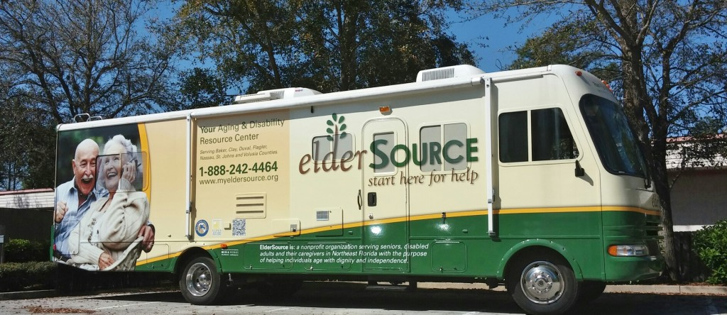

* And much more! Grandparents Day 2015 will be filled  
  with opportunities to help make memories for yesterday’s   
  AND today’s generations. You will not want to miss   
  this annual event.

**For questions   
contact:**

**Heather Corey  
Friends of ElderSource  
Call 904-391-6679**

**Or email**

[**Heather.Corey@myeldersource.org**](mailto:Heather.Corey@myeldersource.org)

[**www.myeldersource.org**](http://www.myeldersource.org)



.



*Community Involvement Opportunities*

Nonprofits are invited to join us for family celebration for all ages! Host an informational table Grandparents Day 2015. Highlight your agency’s services and programs as well as provide a hands-on activity to help families *Make Memories together*!

A free hands-on activity is required to be conducted at each booth. The activity may benefit adults, children and/or both. Promotional publicity materials may be offered AFTER the guests have completed the activity.

Tables will be provided for your booth (an 8-foot table) and (2) folding chairs. Groups will be responsible for their own decorations, supplies and activities. The activities may include *games, photo booth, coloring contest, health screenings, face painting, ancestor research, crafts,* and so forth.

Please keep in mind your available resources (materials, volunteers, 4-hour event, space, attention time, etc.). Activity is based upon first come, first assigned. BOOTH SPACE IS LIMITED and the cost is only $25!

Contact Name: ______________________________________________ Organization: ____________________________________________

Mailing Address: ________________________________________________________________________________________________________

E-mail: ______________________________________________________ Phone Number: __________________________________________

Will you have an activity booth at the event? _____ no _____ yes

Description of activity: _________________________________________________________________________________________________ Will you be providing items for guest goodie bags? ____ no ____ yes.   
Description: _____________________________________________________________________________________________________________

Please enclose check made payable to *Friends of ElderSource for $25.* Or pay by credit card online at [www.myeldersource.org](http://www.myeldersource.org). For any questions, please contact Heather Corey at (904)391-6679 or email at [Heather.Corey@myeldersource.org](mailto:Heather.Corey@myeldersource.org).

***Send completed form to:* Friends of ElderSource  
Attn. Heather Corey**

**10688 Old St. Augustine Road**

**Jacksonville, FL 32257**

Friends of ElderSource is a registered 501(c)3) private nonprofit organization. A copy of the official registration and financial information may be obtained from the division of consumer services by calling, toll-free within the state, 1-800-HELP-FLA or visiting the website [**www.800helpfla.com**](http://www.800helpfla.com). Registration does not imply endorsement, approval or recommendations by the state. REG: CH31757.

Presented by Friends of ElderSource, Northeast Florida’s Area on Aging Agency and Disability Resource Center

Grandparents Day Saturday, September 12, 2015!